## Use Case diagram.

the figure 1.2 is a behaviour diagram that describes a set of actions that the system can perform in collaboraton with the targeted users of the system.

<<include>>

<<extend>>

**Integrated Location-Based Mobile Real Estate Agent for Android**

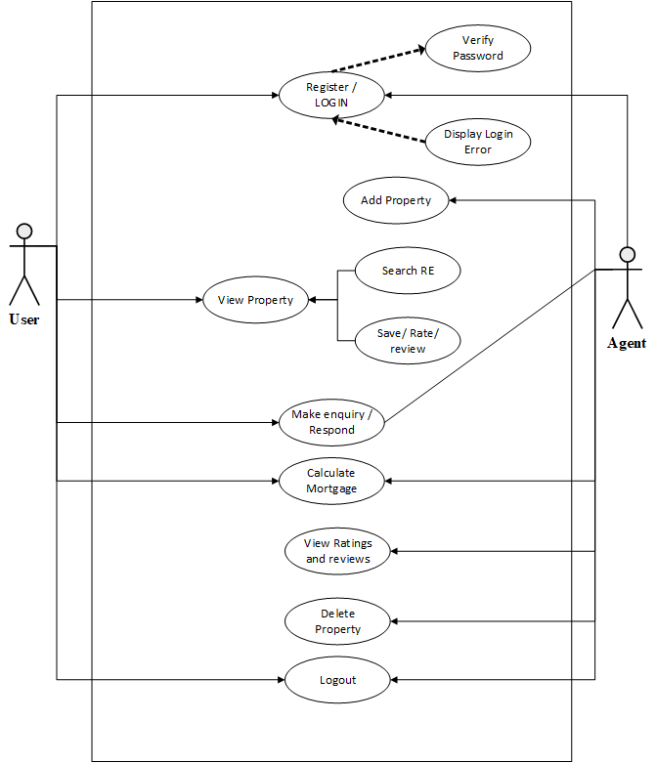

**Figure 1.1: Use case Diagram**

## Basic relation

The figure 1.1 illustrates the basic top-level relation for the interaction within the proposed system.



**Figure 2.2 Basic relation**

## Class Diagram

The class diagram to be used by the system is as follows.

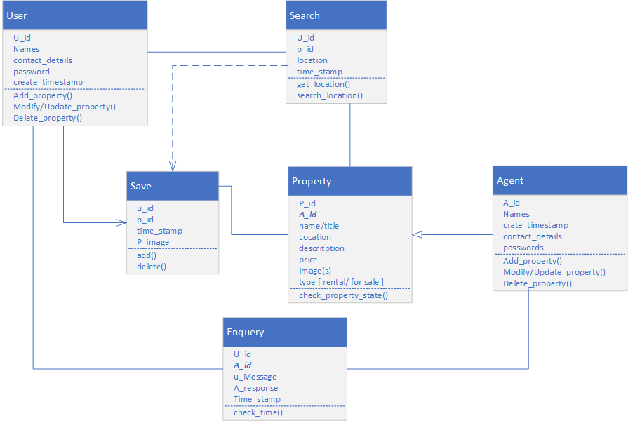

**Figure 3: Class Diagram**

## Entity relationship diagram

The following depicts the entity relationship diagram for the proposed system

